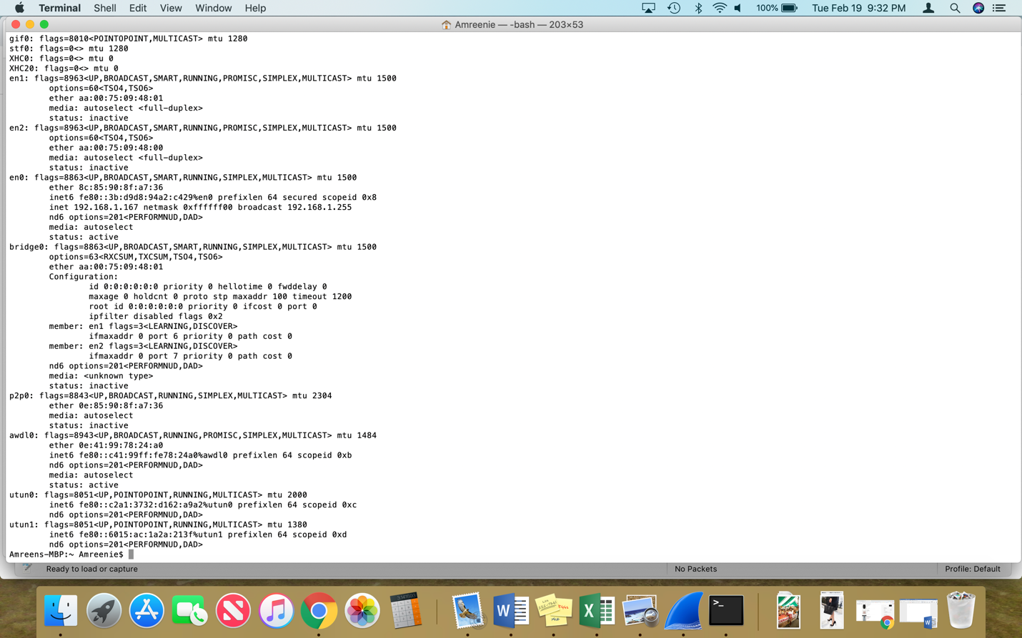

1. What is the TCP port number used by your computer to communicate with gaia.cs.umass.edu?

My computer’s port number is 60631.

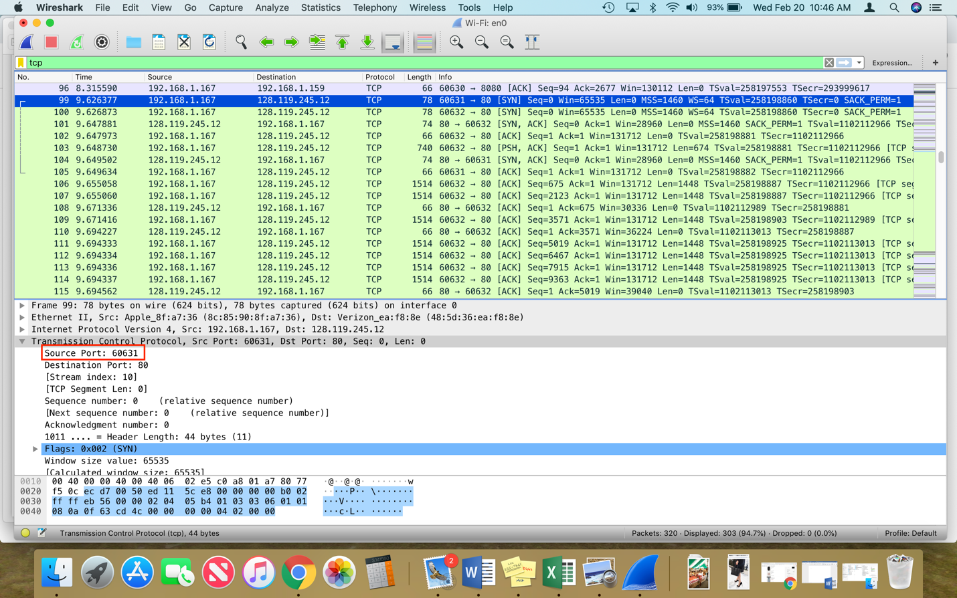

1. What is the TCP port number used by gaia.cs.umass.edu to communicate with your computer?

TCP port number used by the website is 80.

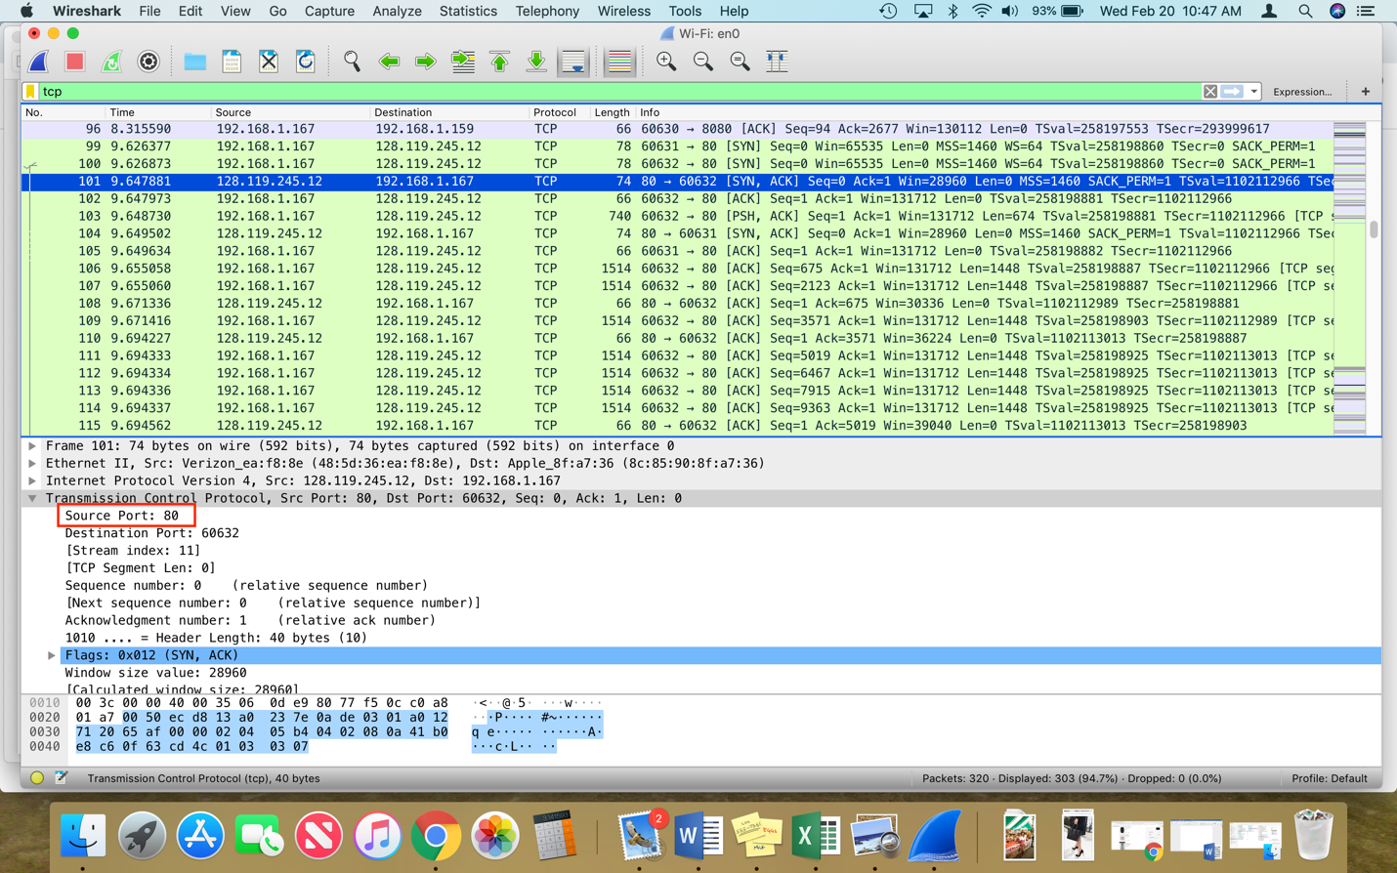

1. What is the sequence number of the TCP SYN segment that is used to initiate the TCP connection between your computer and gaia.cs.umass.edu? What is it in the segment that identifies the segment as a SYN segment?

The sequence number is 0. The way to tell is if the flags are set; in this case the SYN flag is set.

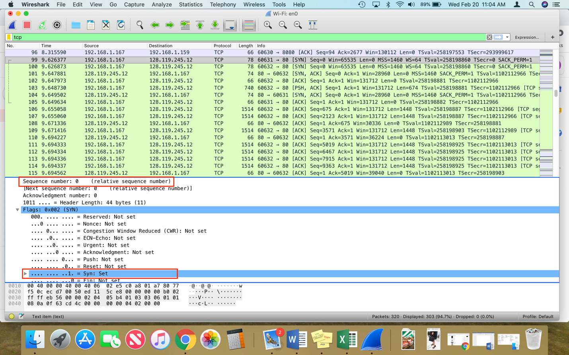

1. What is the sequence number of the SYNACK segment sent by gaia.cs.umass.edu to the client computer in reply to the SYN? - You must dig deep and find the ACK from gaia.cs.umass.edu.

The sequence number of the SYNACK segment is also 0.

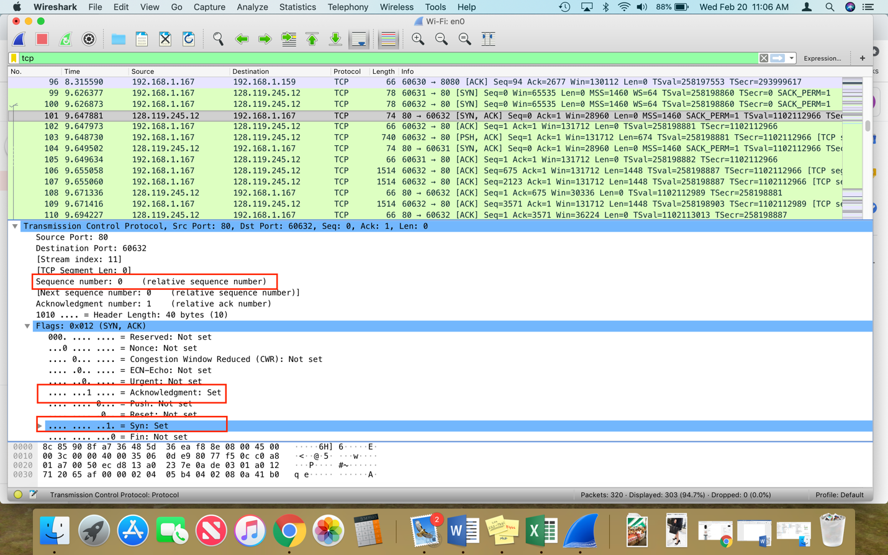

1. What is the sequence number of the TCP segment containing the HTTP POST command? Note: that to find the POST command, you’ll need to dig into the packet content field at the bottom of the Wireshark window, looking for a segment with a “POST” within its DATA field.

The sequence number containing the HTTP POST command is 675.

